Knowledge

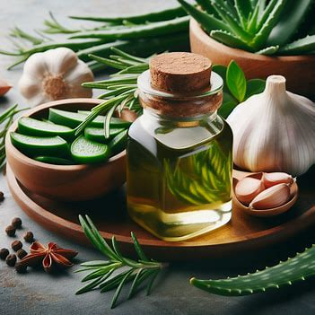

GARLIC

Hair Loss Treatment:

* Garlic contains vitamins, minerals, and antioxidants that nourish hair follicles and promote healthy hair growth.
* It helps strengthen hair strands, reducing breakage and hair loss.
* Garlic's sulfur compounds may contribute to the production of collagen, a protein that supports hair structure and growth.
* Its antibacterial properties can help maintain a clean and healthy scalp, reducing the likelihood of scalp conditions that contribute to hair loss.

Anti-Fungal Activity:

* Garlic's antifungal properties make it effective against various fungal strains, including those causing scalp infections.
* It can help alleviate itching, redness, and inflammation associated with fungal infections on the scalp.
* Garlic's natural compounds may inhibit the growth and spread of fungi, preventing their colonization on the scalp.
* Regular use of garlic-infused products may help maintain a balanced scalp microbiome, reducing the risk of fungal overgrowth.  
  ROSEMARY  
  Hair Loss Treatment:
* Rosemary oil has been found to inhibit the activity of the enzyme 5-alpha reductase, which is involved in the conversion of testosterone to dihydrotestosterone (DHT). By reducing DHT levels, rosemary can help prevent hair follicle miniaturization and hair loss.
* Its soothing properties can help calm an irritated scalp, which may contribute to hair loss.
* Rosemary oil has been shown to increase hair thickness and density, promoting a fuller and healthier appearance.

Anti-Fungal Activity:

* Rosemary contains compounds such as rosmarinic acid, which possess antifungal properties and can help inhibit the growth of fungi on the scalp.
* It can help regulate the production of sebum, an oily substance that can contribute to fungal overgrowth and dandruff.
* Rosemary's antimicrobial activity can aid in reducing scalp itching, redness, and inflammation associated with fungal infections.  
  ALOE VERA

Hair Loss Treatment:

* Aloe vera contains proteolytic enzymes that can repair damaged cells on the scalp and promote hair growth.
* It helps restore the pH balance of the scalp, which can be disrupted by excessive oiliness or product buildup, contributing to hair loss.
* Aloe vera's moisturizing properties can help prevent dryness and flakiness on the scalp, reducing the risk of hair breakage and loss.
* It can help improve blood circulation in the scalp, enhancing the delivery of nutrients to the hair follicles and supporting healthy hair growth.

Anti-Fungal Activity:

* Aloe vera gel has natural antifungal properties that can effectively combat fungal infections on the scalp, such as dandruff or ringworm.
* It helps reduce itching and inflammation associated with fungal scalp infections, providing relief and promoting a healthier scalp.
* Aloe vera's antimicrobial effects can help prevent the proliferation of fungi on the scalp, maintaining a balanced and healthy scalp microbiome.  
  **Common Problems Caused by Skin Fungal Infections**

Skin fungal infections can lead to various issues:

* Itching, irritation, and discomfort.
* Redness, inflammation, and swelling.
* Development of a rash with raised edges.
* Scaling, peeling, and dryness of the skin.
* Changes in skin color.
* Unpleasant odor in specific infections.
* Risk of secondary bacterial infections from scratching.

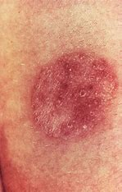 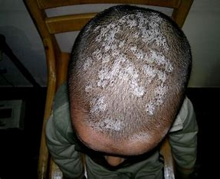

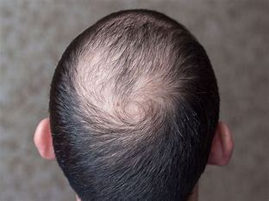

**Common Problems Associated with Hair Loss**

Hair loss can give rise to several challenges and concerns:

* Diminished self-esteem and reduced confidence due to changes in appearance.
* Emotional distress, including feelings of embarrassment, frustration, or anxiety.
* Impact on personal and social life, affecting relationships and social interactions.
* Difficulty in styling hair or trying to conceal thinning areas.
* Increased sensitivity to temperature changes, such as feeling colder without the hair's insulation.
* Heightened vulnerability to sunburn on the scalp.
* Potential impact on professional or career-related aspects, including self-presentation and confidence in the workplace.  
  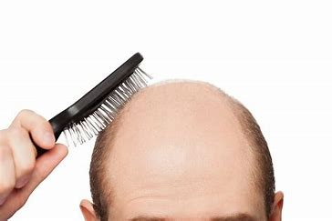 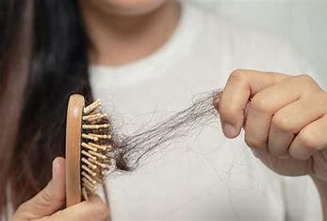

Other parts to be inserted later

ABOUT US

Welcome to Nature'sNurture, a multidisciplinary team of students from ADDIS ABABA SCIENCE AND TECHNOLOGY UNIVERSITY, specializing in Geology, Biotechnology, Industrial Chemistry, and Food Science. Under the guidance of our esteemed advisor, Dr. Tesfaye Eshete, from the Industrial Chemistry Department, we are dedicated to developing innovative and sustainable solutions in the field of hair care.

**Our Project:**

**"The Multifunctional Hair Treatment Oil: Harnessing the Power of Nature"**

At Nature'sNurture, we are committed to harnessing the combined therapeutic properties of natural botanical extracts to create a specialized hair treatment oil. Our project focuses on utilizing the potent qualities of garlic, aloe vera, and rosemary to address hair loss concerns and combat fungal infections, providing a holistic approach to hair and scalp care.

**Objectives:**

Driven by our passion for innovation and sustainable development, our objectives include:

Develop a specialized blend of garlic, aloe vera, and rosemary extracts, optimized for their antifungal properties, to create a potent and effective hair treatment solution.

Formulate a product that nourishes and rejuvenates the scalp, promoting healthy hair growth and addressing the root causes of hair loss.

Foster sustainable practices throughout the production process, ensuring responsible sourcing of ingredients and promoting eco-friendly packaging options.

**Alignment with Sustainable Development Goals (SDGs):**

Nature'sNurture is committed to contributing to the achievement of the United Nations' Sustainable Development Goals (SDGs). Our project aligns with the following SDGs, in addition to the previously mentioned goals:

4. Quality Education: We believe in the power of education and knowledge sharing, actively promoting awareness and providing valuable information on hair care and its impact on personal well-being.

9. Industry, Innovation, and Infrastructure: By embracing innovation and integrating knowledge from various scientific disciplines, we strive to advance the industry and create cutting-edge hair care solutions.

12. Responsible Consumption and Production: Our commitment to responsible sourcing, sustainable practices, and eco-friendly packaging reflects our dedication to minimizing our environmental footprint and promoting conscious consumer choices.

15. Life on Land: Through the utilization of natural botanical extracts, we emphasize the importance of preserving biodiversity and exploring sustainable alternatives to synthetic ingredients.

Our Vision:

At Nature'sNurture, our vision is to be a catalyst for positive change in the hair care industry. By combining the power of nature and scientific expertise, we aim to provide effective, sustainable, and natural solutions that empower individuals to embrace their hair's natural beauty while promoting overall well-being.

Thank you for your interest in Nature'sNurture. We are dedicated to delivering high-quality, environmentally conscious products that meet the expectations of our valued customers. Together, let's embark on a journey of nurturing your hair, naturally.  
  
Other parts(achievement, progress, contact us, Team) will be inserted later

progress  
Date

|  |
| --- |
| Image |

Description

.  
.  
.

Team

|  |
| --- |
| Image |

Name of Advisor  
Specialization  
experience

|  |
| --- |
| Image |

Name of student

Department / field  
contribution  
.  
.  
.

|  |
| --- |
| A group photo of the team |

Achievement

Description

|  |
| --- |
| Image of product obtained at each stage |

DISCUSSION  
………………………………………………………………….  
.  
.  
.  
Description

|  |
| --- |
| Image of product obtained Finally |

DISCUSSION  
…………………………………………………………………  
contact us  
Name of advisor  
email  
ph.number  
office address

Name of student  
email  
ph.number  
.  
.  
.